**Appendix: Data collection and technical details**

# Technical DEtails

The technical details associated with this study are contained in three main sections: (i) Data collation and synthesis – where we outline the broad methodology used to collate, assess and synthesize available country data; (ii) Modelling and investment optimisation methodology – where we describe the analytical approach in detail; and (iii) effectiveness and cost-effectiveness analysis.

## Data Collation and Synthesis

To assess HIV testing and ART programmes among MSM in Bangkok, we collected a large amount of data describing the HIV epidemiology, population demographics, acquisition-related behaviour, clinical characteristics, and program and health costs. To ensure the most up-to-date and accurate evaluation, we collated and synthesized all available data as described in the following sections.

The main data sources include (1) an extensive literature review; (2) database provided by the National Health Security Office (NHSO), Thailand (3) capacity assessment survey in NHSO-listed medical facilities and (4) an empirical study on HIV testing and ART cost breakdown in 13 Bangkok medical facilities.

### Epidemiological and behavioural data

To evaluate the epidemic among MSM in Bangkok, we collected the following indicators from both published and grey literature.

1)Estimated population sizes for men who have sex with men (MSM)

2)The epidemiological characteristics of the HIV epidemic.

* HIV prevalence;
* Annual HIV diagnoses;
* Number of people on ART;

3)Descriptions of risk behaviours, HIV transmission patterns, and health-care seeking behaviour in Bangkok. We used this data to understand modes of HIV transmission between population groups and the risk of HIV acquisition. Specific data collected includes:

* Level of male circumcision;
* Sexual behaviours (e.g. number of sexual partners and level of condom usage in sexual acts);
* Rates at which MSM in Bangkok/Thailand test for HIV.

To ensure all available data was collected, we also performed a systematic literature search for all available data in published articles, conference presentations and reports for MSM in Bangkok. We conducted this by searching PubMed and Medline. Independent searches were conducted for HIV epidemiology, sexual behaviour and HIV clinical factors. Data for HIV biology, HIV infection progression, and HIV mortality are generally independent of population groups and countries. Therefore, we obtained data for these factors from available international literature and meta-analyses reporting the results of rigorous scientific studies.

A primary source of data is from grey literature available from publically accessible websites or through communication with in-country contacts and stakeholders. Some of the key data sources obtained include results from sentinel surveillance sites; integrated biological and/or behavioural surveys conducted among MSM.

4) HIV testing and ART data. The National Health Security Office (NHSO) program provided free HIV testing twice a year for Thai citizen, regardless of health care insurance schemes they have registered, through NHSO-registered HIV testing sites. For Thai people living with HIV who use NHSO scheme (around 70% of Thai people living with HIV), NHSO also provides free antiretroviral treatment (ART), CD4 count twice a year (regardless of ART status), HIV viral load once a year, resistance testing when clinically indicated and other key safety lab tests (for those on ART). NHSO-registered sites need to enter test results and clinical information into the NHSO electronic database in order to get cost reimbursement from NHSO. Number of Thai citizen who accessed HIV testing, number of those who tested HIV-positive, number of HIV-positive people who registered into NHSO system for HIV treatment and care, number of HIV-positive people who started first-line and second-line ART regimens, CD4 count at entry into NHSO system, number of HIV-positive people who achieved undetectable HIV viral load after ART can be obtained by year of services from the database. These indicators can be extracted by service delivery sites in each province.

From epidemiological data collected, we synthesized relevant data to obtain best point estimates and uncertainty ranges for all the parameters used in our modelling evaluation. We collated data over the period 2000 to 2012. Where possible, statistical methods were used to merge multiple sources. Usually, due to limited data, we used a simple weighted average of data from individual studies. However, for many indicators we only collected a single datum value, which we assessed for quality and specified an assumed uncertainty range (usually ±25%). We incorporated all model parameters informed by our data synthesis into a detailed Excel “Optima” spreadsheet.

The Optima spreadsheets contain instructions for data entry with specific worksheets for general population characteristics, demographics, HIV and STI epidemiology, HIV testing and treatment sexual behaviour data, drug use data, biological constants, and health utilities. Where data are available, we have entered a point estimate and an estimated or assumed uncertainty range for each year between 2000 and 2012. For biological constants, we use the same point estimate and range over time. Comments attached to cells provide justifications, calculations, and references for the estimated values based on the collated and synthesized data. A textbox in the first sheet provides further general notes on where we obtained the data, any colour-coding used to classify entries, and key references. Upon receipt of data from sites, data was cleaned, validated and entered into a master spreadsheet to facilitate calculations and analysis of baseline and alternative strategies.

Based on collected epidemiological data, we found that out of 120,000-250,000 MSM in Bangkok, approximately 61,975 (40,200-83,750) MSM were consistently involved in high-risk sexual behaviours and the likely driver of HIV epidemic. Our capacity assessment survey indicated that 14,387 MSM were tested for HIV in 91 Bangkok medical facilities in 2011, corresponding to an overall testing coverage of 27%. Estimated 4,028 MSM were diagnosed to be HIV+, and 3,303 (82%) had CD4 cell count level below 500/ml and were treatment-eligible. NHSO database reported that 989 MSM initiated ART in 2011, corresponding to a 30% treatment commencement rate.

**Figure S1 Low HIV testing and ART commencement rates among high-risk MSM in Bangkok**

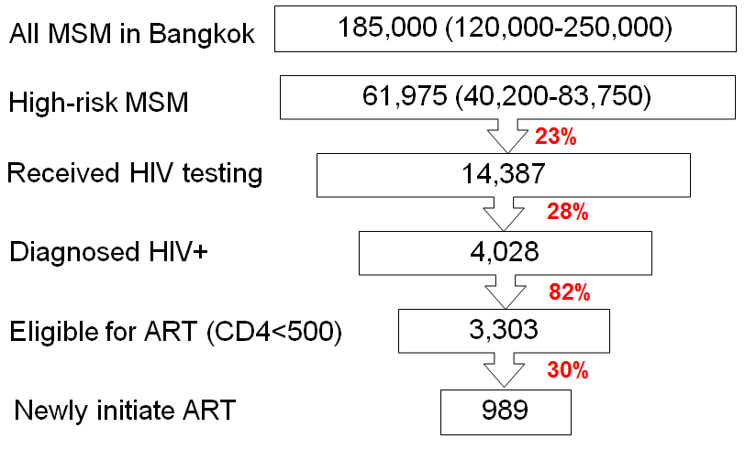

1. ***Mapping of MSM hotspots and medical facilities in Bangkok***

Mapping of MSM hotspots in Bangkok was obtained through previous mapping exercises shared by stakeholders, through internet survey via Adam’s Love website, and experts in the field. These hotspots are related to venues frequented by MSM in Bangkok. Venues mainly include saunas, spas, educational institutions and department stores which are very well known to MSM. In addition, based on the address information provided by NHSO database, we estimated the distance from the facilities to the nearest MSM hotspot on Google Maps.

**Figure S2. Mapping of MSM hotspots and 91 medical facilities in Bangkok**

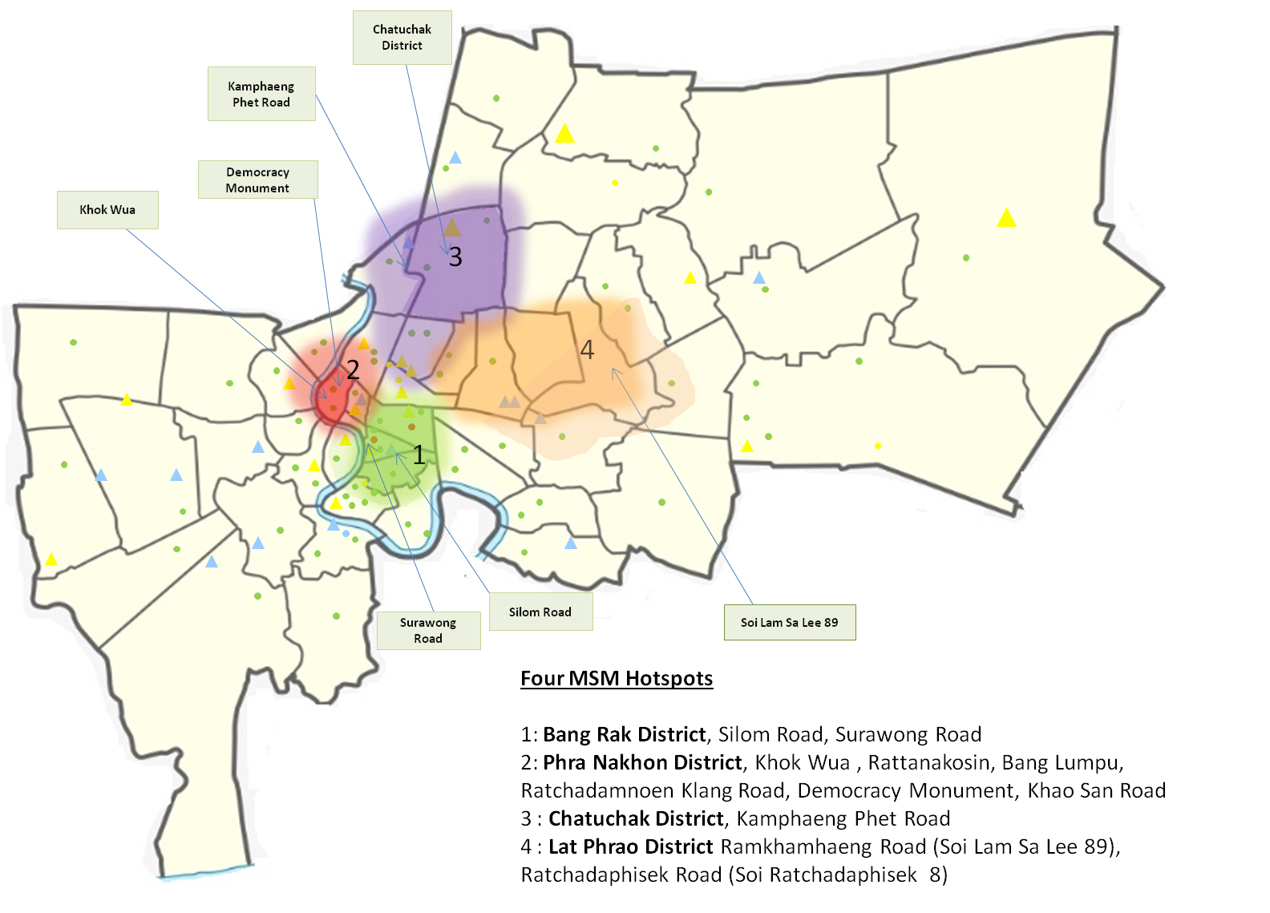

*Legend: Research clinic: red circle; BMA centres that provide HIV testing only: green circle; Public facilities that provide HIV testing only: yellow circle; Private hospitals that provide HIV testing only: blue circle; Public facilities that provide HIV testing and ART: yellow triangle and Private hospitals that provide HIV testing and ART: blue triangle

1. ***Service load and capacity in medical facilities in Bangkok***

We conducted a telephone/letter survey to assess service load and capacity in providing HIV testing and ART services in 91 NHSO-listed medical facilities across Bangkok in 2011. The survey has been intentionally designed to be concise with specific questions on the following aspects: (1) type of the facility; (2) capacity to provide HIV testing; (3) capacity to provide ART; (4) capacity to provide treatment to HIV-related opportunistic infections and co-infections; (5) capacity of HIV reporting and surveillance. The complete survey is listed in Table S1.

**Table S1. Assessment of service provision and capacity of HIV testing and ART sites in Bangkok.**



#### *Costing data for service linkage and provision*

Costing data for service linkage were collected based on a survey of available activities that connect eligible MSM to appropriate HIV testing and ART services. This part of data collection was conducted mostly in collaboration with in-country collaborators and local NGOs that conduct the services. More detail description of the services was provided in Table S7 and S9. In brief, we identified three major recruitment methods of MSM to HIV testing services: (1) conventional community-based outreach via peer-educator; (2) mobile point-of-care (POC) night clinics provided by Thai Red Cross (TRC) and BMA health centres; (3) Adam’s love websites with innovative follow-up technologies hosted by TRC. AIDS Projects Management Group was the organisation that piloted the sole linkage program to facilitate diagnosed and eligible HIV+ MSM to connect to ART services. The linkage model has been named ‘case-management model’ (Table S9). Based on internal reports and communication with the responsible organisations, for each of these linkage programs, we collected indicators on program spending (e.g. cost of implementation and operation) and program effects (e.g. the number of individuals connected to HIV services).

Out of the 91 NHSO-listed medical facilities, 13 were specifically chosen to collect costing data on service provision. The 13 sites were selected based on the current number of MSM who accessed HIV testing and/or ART services at these sites, along with potential capacity to increase the scale of the services in the future. These sites represented public hospitals operated under the Bangkok Metropolitan Administration (BMA) (5 hospitals: Klang, Rajvithi, Taksin, Charoenkrung Pracharak and Vajira Hospitals), private hospitals (2 hospitals: Phyathai 2 and Mongkutwattana General Hospitals), public clinics operated under the BMA (3 clinics: BMA Primary Health Centres 3, 4 and 28), and clinics specialized in MSM and sexual health services (3 clinics: Thai Red Cross Anonymous Clinic, Silom Community Clinic and Bangrak Clinic).

All 13 sites offer HIV testing, and 7 sites offer ART. Of the 7 that offer ART, 2 are private hospitals and 5 are public hospitals. Input data (the costs) and output data (e.g. the number of tests, the number of MSM on treatment) was collected from 13 sites via an input and output costing template. The template was used by a team of data collectors trained by Thai Red Cross in conjunction with key personnel at each of the sites. Overarching data was collected per site, including:

* type of site
* hours of operation
* registration for reimbursement
* spare capacity (to what extent the site can increase volume of clients with existing infrastructure)

Input and output data collected included for testing:

* number of tests (segmented by MSM if possible)
* number tested positive
* number and type of staff and their salaries
* costs of commodities (e.g. test kits, needles)
* operational costs (e.g. telephone, electricity costs)
* [Note: data was not available for rental costs of sites]

Input and output data collected included for ART:

* number of people on 1st, 2nd, 3rd line ART (segmented by MSM if possible)
* cost of monitoring based on:
  + staff time with patients (split by initial 12 months; after 12 months)
  + cost and frequency of monitoring tests
* cost of ART drugs 1st, 2nd line ART

## Modelling Methodology

### Mathematical Model - Optima

To assess HIV epidemic trends and project the cost-effectiveness of investment scenarios, we employed a well-developed mathematical model of HIV transmission and disease progression, called *Optima*. We used this model to calculate the change in HIV incidence, the number of HIV/AIDS deaths due to changes in funding and the cost-effectiveness of various investment scenarios for HIV testing and ART services. Optima uses best-practice HIV epidemic modelling techniques and incorporates realistic biological transmission processes, detailed infection progression and sexual mixing patterns and other high-risk behaviours.

*Optima* incorporates a model of HIV transmission and progression. The model uses a coupled system of ordinary differential equations to track the movement of people between health states (Figure S). The overall population partitioned by group and health state. Individuals are assigned to a given population based on their dominant risk; however, to capture important cross-modal types of transmission and relevant behavioural parameters. The model distinguishes people who are undiagnosed, diagnosed, and on effective anti-retroviral therapy (ART). Diagnosis of HIV-infected individuals occurs based on a HIV testing rate dependent on CD4 count and population type. Similarly, diagnosed individuals begin treatment at a CD4 count dependent rate. The model tracks those on successful first- or second-line treatment (who have an increasing CD4 count) and those with treatment failure.

**Figure S3: HIV Infection Progression**

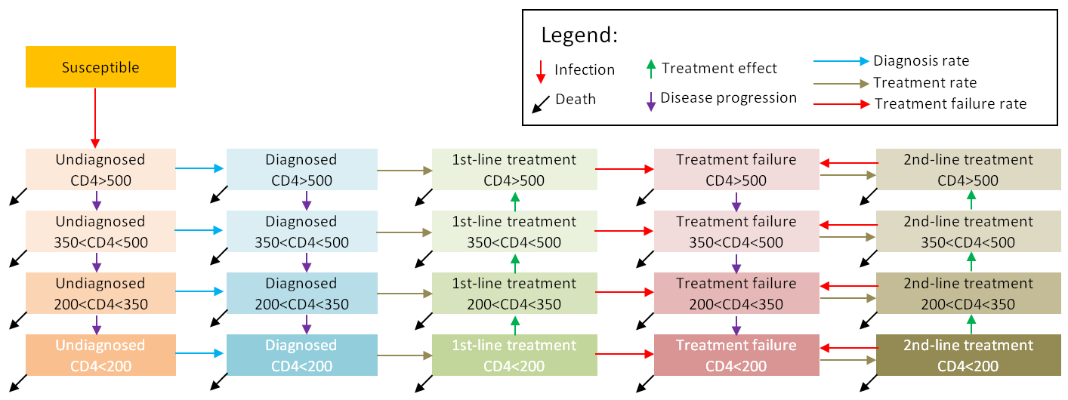

The force-of-infection for a population determines rate at which uninfected individuals within the population become infected. This depends on the number of risk events individuals are exposed to in a given period and the infection probability of each event. Sexual transmission risk depends on:

* The number of people in each HIV-infected stage (that is, the prevalence of HIV infection in partner populations)
* The average number of casual, regular, and commercial homosexual and heterosexual partnerships per person
* The average frequency of sexual acts per partnership
* The proportion of these acts in which condoms are used
* The efficacy of condoms
* The extent of male circumcision
* The prevalence of ulcerative STIs (which increase transmission probability)

The stage of infection (chronic, AIDS-related illness/late stage, or on treatment) for the HIV-positive partner in a serodiscordant couple also influences transmission risk—due to different levels of infectiousness in each infection stage.

Mathematically, we calculate the force-of-infection using:

$$λ=1-{\left(1-β\right)}^{n}$$

where $λ$ is the force-of-infection, $β$ is the transmission probability of each event, and *n* is the effective number of at-risk events (thus *n* gives the average number interaction events with infected people where HIV transmission may occur). The value of the transmission probability $β$ is inversely related to CD4 count, is related to the mode of transmission. The number of events *n* not only incorporates the total number of events, but also other factors that moderate the possibility that these events are capable of transmitting infection. There is one force-of-infection term for each type of interaction (such as, regular, casual and commercial partnerships), and the overall force-of-infection is the sum of overall interaction types.

In addition to the force-of-infection rate, in which individuals move from uninfected to infected states, individuals may move between health states via seven other pathways:

* Individuals may die, either due to the background death rate (which affects all populations equally), due to injecting behaviour, or due to HIV/AIDS (which depends on CD4 count)
* In the absence of intervention, individuals progress from higher to lower CD4 counts
* Individuals can move from undiagnosed to diagnosed states based on their HIV testing rate, which is a function of CD4 count (for example, people with AIDS symptoms have a higher testing rate) and population type (for example, IDUs usually get tested more frequently than low-risk males).
* Diagnosed individuals may move onto treatment, at a rate dependent on CD4 count
* Individuals may move from treatment to treatment failure, and
* From treatment failure onto second-line treatment
* Finally, while on successful first- or second-line treatment, individuals may progress from lower to higher CD4 count.

### Calibration to HIV epidemics

We calibrated Optima to match HIV prevalence data, and the uptake of ART from 2000-2012. While primarily calibrated to match epidemiological data, Optima also optimizes input parameters to match available demographic, behavioural, biological and clinical data. Given the challenges inherent in quantifying all known constraints on an epidemic, we calibrated the model manually, with oversight by and collaboration with in-country stakeholders where possible. The values of each parameter in 2012 represent current conditions for each simulation.

**Figure S4. Calibration of *Optima* to the HIV epidemic among MSM in Bangkok during 2000-2012 , (a) HIV prevalence; (b) number of diagnosed HIV+ MSM on ART**

(a)

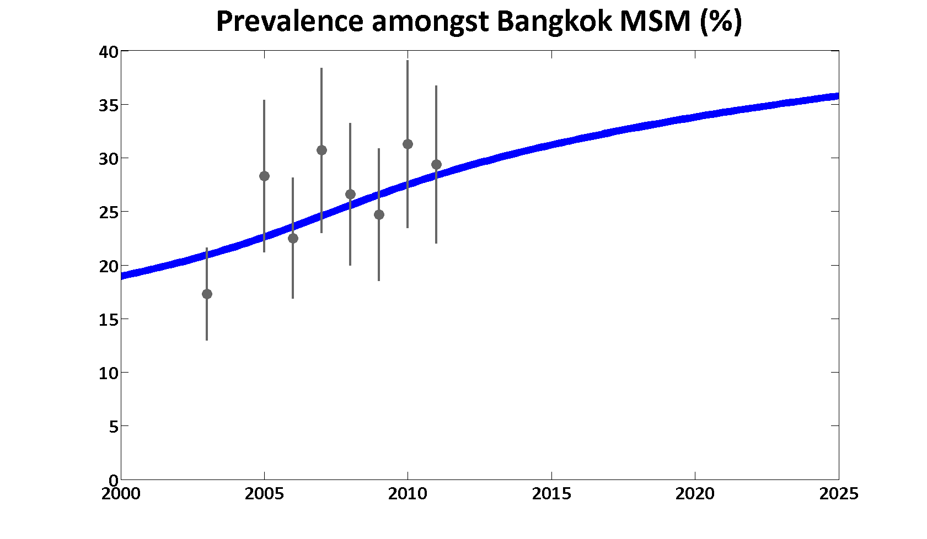

(b)

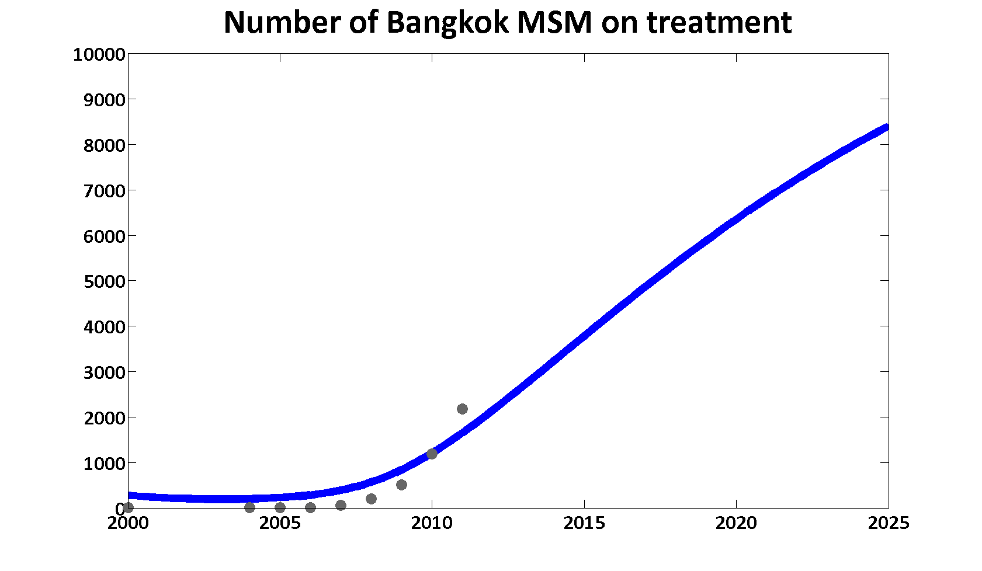

***Uncertainty analyses***

Optima uses a Markov chain Monte Carlo (MCMC) algorithm for performing automatic calibration and for computing uncertainties in the model fit to epidemiological data. With this algorithm, the model is run a large number of times (~10000) to generate a range of epidemic projections; their differences represent uncertainty in the expected epidemiological trajectories. The calibration and optimisation processes incorporate uncertainties in all parameters. In particular, this includes uncertainties in demographic indicators (e.g. population size), epidemiological data (e.g. HIV prevalence), behavioural indicators (e.g. the number of sexual partners, the frequency of sexual acts and the percentage of condom usage) and costing data (e.g. unit price of providing HIV testing and antiretroviral treatment). All available historical spending data and achieved outcomes of spending, data from comparable settings, experience, and extensive discussion with stakeholders in Thailand to inform these ranges. All parameters within these ranges are then allowable and are incorporated into uncertainty analyses of Optima. These fitting of the model are thus reconciled with the epidemiological, behavioral, and biological data in a Bayesian-optimal way, thereby allowing the calculation of unified uncertainty estimates.

***Estimation of unit cost of service provision***

The total cost of a service is calculated as sum of all expenses incurred during the provision of the services. The breakdown of items for HIV testing and ART provision is listed in Table S8 and Table 10. Fixed costs were defined as those expenses that remain constant during a relevant period regardless of the number of people served. These may include cost for program management (planning, administration, and supervision), training, travel, purchase and operation of mobile vans, durable goods, and equipment. In contrast, variable costs were those for recruitment, counselling and testing, and nondurable goods and commodities, such as testing kits, materials for screening and confirmatory testings (Shrestha RK Public Health Rep. 2008 Nov-Dec;123 Suppl 3:94-100.). The unit cost of service provision is hence the ratio of total service costs and the number of person-time the service has been provided. We adapted a similar definition of cost function for the calculation of unit cost in our study (Gesine Meyer-Rath, Mead Over, PloS One. 2012 Jul; 9(7):1-10.). Namely,

$$U_{i}= \frac{F_{i}+u_{i}∙N_{i}}{N_{i}}$$

Where *U* denotes unit cost, *F* is the total amount of fixed costs, *u* is the unit variable cost (e.g. commodity cost of providing one HIV test) and the *N* is the number of person-times the service is provided (e.g. number of tests conducted among MSM in the past 12 months). The index ‘*i*’ denotes the type of medical facility where the service has been provided. The same formula applies to both HIV testing and ART services. The relationship between *U* and *N* is illustrated in Figure S5.

***Optimisation of resources for services scale-up***

In this study, we aim to investigate the most economical way of scaling-up ART coverage among Bangkok MSM and forecast their subsequent epidemiological impacts and value for money. The three ART scale-up scenarios we investigated are to achieve universal ART coverage among Bangkok high-risk MSM by 2022, 2017 and 2015 respectively. The differences in epidemiological outcomes between these scenarios and the projected status quo provided the basis for the evaluation of the effectiveness and cost-effectiveness of the scenarios.

The two key indicators for optimising service sources are the HIV testing rate (*X*) and annual ART commencement rate (*Y*). If these rates increased from currently ( $x_{0},y_{0})$ to (${x+x}_{0},{y+y}_{0})$, extra number (*T*) of MSM living with HIV will initiate ART, with the expression:

$T=N∙p∙η∙[\left(x+x_{0}\right)\left(y+y_{0}\right)-x_{0}y_{0}]$,

Where $N$ is the population size of MSM, $p$ is HIV prevalence and $η$ is the proportion of HIV+ MSM who are eligible for treatment (with treatment threshold CD4<500/ml). On the other hand, the intended scaled-up ART coverage (*R*) has the expression:

$R={(T+T_{0})}/{(E+T_{0}})$*.*

Therefore,

$$T={(R-R_{0})}/{(E+T_{0}})$$

, where *E* is the number treatment-eligible individuals that are yet on ART, and $T_{0}$ and $R_{0}$ are current number of individuals on ART and ART coverage respectively. Since both $Npη$ and $E+T_{0}$ represent the number of individuals should be on ART, the expression of coverage, as a function of HIV testing rate and ART commencement rate can be simplified as:

$R-R_{0}=\left(x+x_{0}\right)\left(y+y_{0}\right)-x_{0}y_{0}$.

The intended coverage increase will require extra cost *C*:

$$C=\underset{\begin{aligned}Cost for \\ extra testing \\ linakge\end{aligned}}{\underbrace{Nxc_{1}}}+\underset{\begin{aligned}Cost for \\ extra testing \\ provision\end{aligned}}{\underbrace{Nxpc_{2}}}+\underset{\begin{aligned}Cost for \\ extra ART \\ linkage\end{aligned}}{\underbrace{Npη[\left(x+x_{0}\right)\left(y+y_{0}\right)-x_{0}y_{0}]c_{3}}}+\underset{\begin{aligned}Cost for \\ extra ART \\ prvision\end{aligned}}{\underbrace{Npη[\left(x+x_{0}\right)\left(y+y_{0}\right)-x_{0}y_{0}]c_{4}}}$$

, where $c_{1}$ to $c_{4}$ are the unit costs to each step of service linkage and provision. In fact, we assume the unit cost for HIV testing linkage $c_{1}$ is a constant $36 per person and unit cost for ART service linkage $c_{3}$ is $178 (Table S7, S9), whereas unit cost for HIV testing and ART provision ( $c_{2}$ and $c_{4}$) could be minimised according to the type of facility for service provision.

The objective function for optimising HIV testing services is:

$$C_{3}=\sum{Y_{i}∙μ_{i}+X_{i}∙η_{i}}$$

Where, $μ_{i}$ is the average unit material cost of a HIV test (averaged over the costs of screening, confirmatory tests and needle and syringes); $η_{i}$ is the cost of establishing a new HIV testing site of equal size in the currently existing facility (assuming space available); $X_{i}=ceiling\left(\frac{Y_{i}-α_{i}}{\overline{α_{i}}}\right)$ is the number of new facilities required, in which $α_{i}$ represents the current availability for HIV testing in the facilities and $\overline{α_{i}}$ represents the maximum capacity for HIV testing in the same facility. The optimisation is subjected to the constraint $\sum{Y_{i}=τ}$, where $Y_{i}$ is the number of tests conducted at the facility with type $i$ ( $i$ can be Public HIV testing and ART providers, BMA clinics, private hospitals and research clinics); $τ$ is the total number of HIV tests required. The objective function unit cost for ART provision $c_{4}$ follows a similar expression.

***Forecasting epidemiological impacts and cost-effectiveness***

We project the trajectory of HIV epidemic among Bangkok MSM over the period of 2013-2022. The key epidemiological indicators include the number of new HIV cases, HIV-related deaths and number of people on ART. We compare these indicators across the scenarios. We used disability-adjusted life years (DALYs) to measure the overall impact of HIV programs and for basic health economic calculations. The most thorough empirical study of disability weights is the 2010 Global Burden of Disease Study (Salomon, et.al., The Lancet, 2013). This study reports DALYs for people with symptomatic HIV, AIDS, and HIV but on effective HIV treatment (Table S2).

**Table S2: Disability weights for HIV related health states from the 2010 Global Burden of Disease Study.**

|  |  |
| --- | --- |
| **Health State** | **Estimated DALY**  **(95% uncertainty interval)** |
| HIV: symptomatic, pre-AIDS | 0·221 (0·146–0·310) |
| HIV/AIDS: receiving antiretroviral treatment | 0·053 (0·034–0·079) |
| AIDS: not receiving antiretroviral treatment | 0·547 (0·382–0·715) |

Based on the results from the Global Burden of Disease Study (Salomon, et.al., The Lancet, 2013) we assigned a disability-weight for HIV-positive people in each CD4 count category (Table S3).

**Table S3: Assumed disability-weights for DALY calculations. The disability-weight for HIV-positive MSM is the maximum of the value for HIV-negative MSM and the corresponding HIV-positive category disability weight.**

|  |  |
| --- | --- |
| Population category | Assumed Disability-Weight |
|  |  |
| HIV-negative (MSM) | 0.250 |
| Untreated HIV-positive: CD4 > 500 | 0.221 |
| Untreated HIV-positive: 350 < CD4 < 500 | 0.221 |
| Untreated HIV-positive: 200 < CD4 < 300 | 0.221 |
| Untreated HIV-positive: CD4 < 200 | 0.547 |
| Treated HIV-positive: CD4 > 500 | 0.053 |
| Treated HIV-positive: 350 < CD4 < 500 | 0.053 |
| Treated HIV-positive: 200 < CD4 < 300 | 0.053 |
| Treated HIV-positive: CD4 < 200 | 0.053 |

Based on the forecasted epidemiological outcomes, we calculated costs required for each HIV-related death, new HIV case and DALY averted. The strategy is considered to cost-saving if cost per DALY averted is less than one GDP per capita and cost-effective if less than three GDP per capita. We used a discounting rate of 3% for costs and DALYs.

**Table S4. Facility characteristics and operational capacity of HIV testing services in 91 Bangkok medical facilities. Site information was obtained from the National Health Security Office (NHSO) database, service load and capacity data from capacity assessment survey, and distance information from site mapping exercise.**

|  |  |  |  |  |  |  |  |
| --- | --- | --- | --- | --- | --- | --- | --- |
| **Hospital name** | **Hospital CODE** | **Facility Type** | **Distance categorisation** | **Total number of HIV tests conducted in 2011** | **Total HIV tests conducted among MSM** | **Maximum HIV testing capacity per year** | **Current service loading** |
| The Thai Red Cross AIDS Research Centre | 23220 | Research clinic | Hotspot catchment | 27,624 | 8,544 | 28,703 | 96.2% |
| Silom Clinic | Silom | Research clinic | Hotspot catchment | 2,297 | 2,297 | 2,880 | 79.8% |
| Correctional Hospital-State-Own | 11468 | Public facilities | Hotspot catchment | 1,766 | 8 | 1,800 | 98.1% |
| Lerdsin Hospital | 11469 | Public facilities | Hotspot catchment | 16 | 0 | N/A |  |
| Nopparatrajathanee Hospital | 11470 | Public facilities | Within 5-10km | 114 | 0 | N/A |  |
| Rajavithi Hospital | 11472 | Public facilities | Within 5km | 66,330 | 3,317 | 71,864 | 92.3% |
| Phramongkutklao Hospital | 11481 | Public facilities | Within 5-10km | 10 | 0 | 24,000 | 0.0% |
| (Bhumibol Adulyadej Hospital RTAF)-Stateown | 11482 | Public facilities | Over 10km | 51 | 0 | N/A |  |
| Faculty of Medicine Vajira Hospital, University of Bangkok Metropolis . | 11535 | Public facilities | Within 5km | 283 | 86 | N/A |  |
| Vetchakarunrat Hospital | 11536 | Public facilities | Over 10km | 1,751 | 0 | N/A |  |
| Klang Hospital | 11537 | Public facilities | Within 5km | 7,469 | 0 | 8,268 | 90.3% |
| Taksin Hospital | 11539 | Public facilities | Within 5km | 13,467 | 19 | 7,280 | 185.0% |
| Luang Por Thaweesak Chutinatharo Uthit Hospital | 11540 | Public facilities | Over 10km | 43 | 0 | 1,680 | 2.6% |
| Charoenkrung Pracharak Hospital | 11541 | Public facilities | Within 5-10km | 321 | 1 | 12,000 | 2.7% |
| Mahesak Hospital-Private Hospital | 11552 | Private facilities | Hotspot catchment | 80 | 17 | 1,668 | 4.8% |
| Praram 2 Hospital | 11647 | Public facilities | Over 10km | 85 | 0 | N/A |  |
| Queen Sirikit National Institute Of Child Health | 12438 | Public facilities | Within 5km | 28 | 0 | N/A |  |
| Primary Health Center 6 | 13651 | Public facilities | Within 5-10km | 105 | 0 | 300 | 35.0% |
| Primary Health Center 7 Boonmee Pururatrangsan | 13652 | Public facilities | Within 5-10km | 185 | 2 | 480 | 38.5% |
| Health Center 8 Bunrood Rungloung | 13653 | Public facilities | Over 10km | 677 | 1 | 1,200 | 56.4% |
| Health Center 9 Prachatibpatri | 13654 | Public facilities | Hotspot catchment | 177 | 0 | N/A |  |
| Primary Health Center 11 | 13656 | Public facilities | Within 5km | 40 | 1 | 360 | 11.1% |
| Health Center 21 Wat Tad Thong | 13666 | Public facilities | Within 5-10km | 606 | 0 | 1,440 | 42.1% |
| Health Center 22 Watpakboi | 13667 | Public facilities | Within 5-10km | 1,235 | 0 | 1,392 | 88.7% |
| Health Center 23 Siphraya | 13668 | Public facilities | Hotspot catchment | 39 | 0 | 3,600 | 1.1% |
| Health Center 24 Bang Khen | 13669 | Public facilities | Hotspot catchment | 207 | 0 | 300 | 69.0% |
| Health Center 29 | 13674 | Public facilities | Within 5-10km | 296 | 1 | 420 | 70.5% |
| Health Center 55 Thachasumpan | 13698 | Public facilities | Within 5-10km | 14 | 0 | 600 | 2.3% |
| Health Center 58 Lom Pimsen Fukudom | 13701 | Public facilities | Over 10km | 138 | 0 | 360 | 38.3% |
| Health Center 61 Sangwan Thassanaroum | 13704 | Public facilities | Over 10km | 415 | 0 | 432 | 96.1% |
| (Police Hospital)-State Own | 14173 | Public facilities | Hotspot catchment | 782 | 2 | 8,400 | 9.3% |
| Ratchpipat Hospital | 14641 | Public facilities | Over 10km | 1,012 | 7 | N/A |  |
| Sirindhorn hospital Under the Department of Health | 15049 | Public facilities | Over 10km | 1,736 | 0 | 7,200 | 24.1% |
| kluaynamthai 1 Hospital | 11583 | Private hospital | Within 5-10km | 6,644 | 6 | N/A |  |
| Navamin Hospital-Private Hospital | 11595 | Private hospital | Within 5-10km | 40 | 4 | N/A |  |
| Bangphai General Hospital-Private | 11621 | Private hospital | Within 5-10km | 50 | 0 | N/A |  |
| Khlong Tan Hospital-Private | 11626 | Private hospital | Hotspot catchment | 773 | 13 | 960 | 80.5% |
| Petcharavej Hospital | 11629 | Private hospital | Hotspot catchment | 90 | 2 | N/A |  |
| Vichaivej International Hospital | 11641 | Private hospital | Within 5km | 2 | 0 | N/A |  |
| Petchakasem Bangkhae Health center | 11652 | Private hospital | Over 10km | 10 | 0 | N/A |  |
| Navamin 2 Hospital-Private Hospital | 11667 | Private hospital | Over 10km | 67 | 1 | N/A |  |
| Krungthon 2 Hospital | 11668 | Private hospital | Within 5-10km | 96 | 2 | N/A |  |
| (Dr.Panya General Hospital)-Private Hospital | 11703 | Private hospital | Hotspot catchment | 3 | 0 | N/A |  |
| Bangmod Hospital-Private Hospital | 11708 | Private hospital | Over 10km | 168 | 0 | N/A |  |
| Mongkutwatthana hospital | 11722 | Private hospital | Over 10km | 6,538 |  | 69,888 | 9.4% |
| Hua Chiew Hospital | 11750 | Private hospital | Within 5km | 32 | 0 | N/A |  |
| Primary Health Center 65 Raksasuk bang bon | 21486 | BMA health center | Over 10km | 255 | 0 | 408 | 62.5% |
| Primary health care center 1 Sapanmorn | 13646 | BMA heath center | Hotspot catchment | 77 | 0 | 180 | 42.8% |
| Primary Health Center 3 | 13648 | BMA heath center | Within 5km | 754 | 5 | 825 | 91.4% |
| Health Center 4 Din Daeng | 13649 | BMA heath center | Within 5-10km | 935 | 2 | N/A |  |
| Primary health care center 5 Chulalongkorn | 13650 | BMA heath center | Hotspot catchment | 213 | 1 | 300 | 71.0% |
| Health Center 10 Sukumvit | 13655 | BMA heath center | Within 5-10km | 142 | 0 | 264 | 53.8% |
| Health Center 12 Chantieng Natrvisas | 13657 | BMA heath center | Within 5-10km | 18 | 0 | 84 | 21.4% |
| Health Center 14 Kaew Sriboonrueng | 13659 | BMA heath center | Within 5km | 70 | 0 | 6,000 | 1.2% |
| Primary health care center 18 Mongkol Worn Wang Tarn | 13663 | BMA heath center | Within 5km | 13 | 0 | 600 | 2.2% |
| Health Center 19 Wongsawang | 13664 | BMA heath center | Within 5-10km | 22 | 0 | N/A |  |
| Primary health care center 20 Siam City Bank | 13665 | BMA heath center | Within 5km | 41 | 0 | N/A |  |
| Health Center 25 Huai Khwang | 13670 | BMA heath center | Hotspot catchment | 312 | 0 | 444 | 70.3% |
| (Health Center 26 haokhunpraprayurawong) | 13671 | BMA heath center | Within 5km | 76 | 0 | 240 | 31.7% |
| Health Center 27 Junt Chimpiboon | 13672 | BMA heath center | Within 5-10km | 91 | 0 | N/A |  |
| Health Center 28 Krung Thon Buri | 13673 | BMA heath center | Within 5km | 484 | 33 | 600 | 80.7% |
| Primary health care center 30 Wat-Chaoarm | 13675 | BMA heath center | Within 5-10km | 115 | 0 | 240 | 47.9% |
| Health Center 31 Erb-Chit Tangsubutr | 13676 | BMA heath center | Within 5-10km | 220 | 0 | 240 | 91.7% |
| Primary health care center 32 Maris Tintamusik | 13677 | BMA heath center | Over 10km | 41 | 0 | 480 | 8.5% |
| Health Center 33 Wat Hongrattaram | 13678 | BMA heath center | Within 5-10km | 124 | 0 | 600 | 20.7% |
| Health center 34 | 13679 | BMA heath center | Over 10km | 25 | 0 | 2,400 | 1.0% |
| Health Center 36 Bukkhalo | 13681 | BMA heath center | Within 5-10km | 187 | 0 | 240 | 77.9% |
| Health Center 38 Jeed Tongkum Bumpen | 13683 | BMA heath center | Within 5km | 39 | 2 | 84 | 46.4% |
| Health Center 39 Rat Burana | 13684 | BMA heath center | Within 5-10km | 143 | 0 | 240 | 59.6% |
| Health Center 40 Bang Khae | 13685 | BMA heath center | Over 10km | 447 | 10 | 1,128 | 39.6% |
| Bangkok Health Center 41 Klongtoey | 13686 | BMA heath center | Within 5-10km | 322 | 0 | 1,512 | 21.3% |
| Health Center 42 Tanom Tongsima | 13687 | BMA heath center | Over 10km | 321 | 0 | 720 | 44.6% |
| Health Center 43 Min Buri | 13688 | BMA heath center | Within 5-10km | 745 | 0 | 2,640 | 28.2% |
| Health Center 46 Kantaratutis | 13689 | BMA heath center | Over 10km | 540 | 0 | 660 | 81.8% |
| Health Center 47 | 13690 | BMA heath center | Over 10km | 138 | 0 | 120 | 115.0% |
| Health Center 48 Nakvatcharaoutid | 13691 | BMA heath center | Over 10km | 61 | 0 | 432 | 14.1% |
| Health Center 49 Wat Chaiyaprukmala | 13692 | BMA heath center | Over 10km | 154 | 0 | N/A |  |
| Health Center 50 Bung Kum | 13693 | BMA heath center | Hotspot catchment | 79 | 0 | 600 | 13.2% |
| Health Center 51 Wat Phaiton | 13694 | BMA heath center | Within 5km | 273 | 0 | 600 | 45.5% |
| Primary Health Center 52 | 13695 | BMA heath center | Hotspot catchment | 91 | 0 | 240 | 37.9% |
| Health Center 53 Tungsonghong | 13696 | BMA heath center | Over 10km | 7 | 0 | N/A |  |
| Health Center 54 Tudaeim | 13697 | BMA heath center | Over 10km | 26 | 0 | 84 | 31.0% |
| Primary health care center 56 Tabchalearn | 13699 | BMA heath center | Over 10km | 193 | 1 | 240 | 80.4% |
| Health center 57 | 13700 | BMA heath center | Over 10km | 21 | 1 | 180 | 11.7% |
| Health Center 60 Rossukon Manoshayakorn | 13703 | BMA heath center | Over 10km | 126 | 0 | N/A |  |
| Public Health Center 63 The Tio Chew Association of Thailand | 14818 | BMA heath center | Hotspot catchment | 42 | 0 | 264 | 15.9% |
| Health Center 44 Lampakchi | 21526 | BMA heath center | Over 10km | 4 | 0 | N/A |  |
| Public Health Center 45 Romklao | 21755 | BMA heath center | Within 5-10km | 571 | 0 | N/A |  |
| Health center 64 | 22455 | BMA heath center | Over 10km | 53 | 0 | 180 | 29.4% |
| Health centers, 68 | 23159 | BMA heath center | Hotspot catchment | 188 | 0 | N/A |  |
| Health Center 67 Taweewattana | 23229 | BMA heath center | Over 10km | 133 | 0 | N/A |  |
| Primary health care center 16 Lumpini | 13661 | BMA heath center | Hotspot catchment | 11 | 0 | N/A |  |

**Table S5. Facility characteristics and operational capacity of ART services in 48 Bangkok medical facilities. Data was obtained from the National Health Security Office (NHSO), Thailand**

|  |  |  |  |  |  |  |
| --- | --- | --- | --- | --- | --- | --- |
| **Hospital Name** | **Hospital CODE** | **Type of facility** | **Distance to the nearest MSM hotspots** | **Number of people on ART in 2011** | **Maximum Capacity of ART provision** | **Current service loading** |
| Health Center 61 Sangwan Thassanaroum | 13704 | Public facility | Over 10km | 1 | N/A |  |
| Health Center 9 Prachatibpatri | 13654 | Public facility | Hotspot catchment | 39 | N/A |  |
| (Bhumibol Adulyadej Hospital RTAF)-Stateown | 11482 | Public facility | Over 10km | 2,271 | N/A |  |
| (Police Hospital)-State Own | 14173 | Public facility | Hotspot catchment | 778 | 1,200 | 64.83% |
| (Somdejprapinklao Hospital)-State Own | 11478 | Public facility | Within 5-10km | 1,429 | N/A |  |
| Charoenkrung Pracharak Hospital | 11541 | Public facility | Within 5-10km | 2,863 | 2,868 | 99.83% |
| Chulalongkorn Hospital | 13756 | Public facility | Hotspot catchment | 387 | N/A |  |
| Correctional Hospital-State-Own | 11468 | Public facility | Hotspot catchment | 3,792 | 5,100 | 74.35% |
| Faculty of Medicine Vajira Hospital, University of Bangkok Metropolis. | 11535 | Public facility | Within 5km | 2,192 | N/A |  |
| Health Center 1 | 13674 | Public facility | Within 5-10km | 56 | 120 | 46.67% |
| Health Center 21 Wat Tad Thong | 13666 | Public facility | Within 5-10km | 75 | N/A |  |
| Health Center 22 Watpakboi | 13667 | Public facility | Within 5-10km | 24 | N/A |  |
| Health Center 23 Siphraya | 13668 | Public facility | Hotspot catchment | 0 | N/A |  |
| Health Center 24 Bang Khen | 13669 | Public facility | Hotspot catchment | 0 | N/A |  |
| Health Center 58 Lom Pimsen Fukudom | 13701 | Public facility | Over 10km | 1 | N/A |  |
| Health Center 8 Bunrood Rungloung | 13653 | Public facility | Over 10km | 24 | 48 | 50.00% |
| Klang Hospital | 11537 | Public facility | Within 5km | 2,654 | N/A |  |
| Lerdsin Hospital | 11469 | Public facility | Hotspot catchment | 1,103 | N/A |  |
| Luang Por Thaweesak Chutinatharo Uthit Hospital | 11540 | Public facility | Over 10km | 1,004 | 3,708 | 27.08% |
| Mahesak Hospital-Private Hospital | 11552 | Public facility | Hotspot catchment | 1,121 | 1,200 | 93.42% |
| Nopparatrajathanee Hospital | 11470 | Public facility | Within 5-10km | 1,391 | N/A |  |
| Phramongkutklao Hospital | 11481 | Public facility | Within 5-10km | 980 | N/A |  |
| Praram 2 Hospital | 11647 | Public facility | Over 10km | 2,472 | N/A |  |
| Primary Health Center 11 | 13656 | Public facility | Within 5km | 0 | 360 | 0.00% |
| Primary Health Center 6 | 13651 | Public facility | Within 5-10km | 2 | N/A |  |
| Primary Health Center 7 Boonmee Pururatrangsan | 13652 | Public facility | Within 5-10km | 0 | N/A |  |
| Rajavithi Hospital | 11472 | Public facility | Within 5km | 3,437 | 9,600 | 35.80% |
| Ratchpipat Hospital | 14641 | Public facility | Over 10km | 1,542 | N/A |  |
| Sirindhorn hospital Under the Department of Health | 15049 | Public facility | Over 10km | 2,119 | 4,800 | 44.15% |
| Siriraj Hospital | 13814 | Public facility | Within 5km | 3,863 | 12,000 | 32.19% |
| Taksin Hospital | 11539 | Public facility | Within 5km | 5,192 | 9,600 | 54.08% |
| Vetchakarunrat Hospital | 11536 | Public facility | Over 10km | 1,591 | N/A |  |
| (Dr.Panya General Hospital)-Private Hospital | 11703 | Private hospital | Hotspot catchment | 4,592 | N/A |  |
| Bangmod Hospital-Private Hospital | 11708 | Private hospital | Over 10km | 320 | 324 | 98.77% |
| Bangna Hospital 1 | 11592 | Private hospital | Over 10km | 3 | N/A |  |
| Bangphai General Hospital-Private | 11621 | Private hospital | Within 5-10km | 1,078 | N/A |  |
| Hua Chiew Hospital | 11750 | Private hospital | Within 5km | 560 | N/A |  |
| Kasemrad prachachuen hospital-Private Hospital | 11687 | Private hospital | Within 5km | 28 | 4,932 | 0.57% |
| Khlong Tan Hospital-Private | 11626 | Private hospital | Hotspot catchment | 921 | 1,440 | 63.96% |
| kluaynamthai 1 Hospital | 11583 | Private hospital | Within 5-10km | 2,399 | N/A |  |
| Krungthon 2 Hospital | 11668 | Private hospital | Within 5-10km | 283 | N/A |  |
| Lat Krabung Hospital | 11538 | Private hospital | Over 10km | 762 | 2,400 | 31.75% |
| Mongkutwatthana hospital | 11722 | Private hospital | Over 10km | 1,985 | 2,400 | 82.71% |
| Navamin 2 Hospital-Private Hospital | 11667 | Private hospital | Over 10km | 1,040 | N/A |  |
| Navamin Hospital-Private Hospital | 11595 | Private hospital | Within 5-10km | 1,629 | N/A |  |
| Petchakasem Bangkhae Health center | 11652 | Private hospital | Over 10km | 966 | N/A |  |
| Petcharavej Hospital | 11629 | Private hospital | Hotspot catchment | 307 | N/A |  |
| Vichaivej International Hospital | 11641 | Private hospital | Within 5km | 346 | N/A |  |

**Table S6, Service load and capacity for (a) HIV testing services in 91 and (b) ART services in 48 Bangkok medical clinics in 2011, stratified by facility types and distances to MSM hotspots.** Association between distances to MSM hotspots and servicing loads are not statistically significant for both services (Spearman Correlation, HIV testing: *r*=-0.0449, *p*= 0.7341; ART: *r*=-0.2110, *p*=0.4163).

**(a)**

|  |  |  |  |  |
| --- | --- | --- | --- | --- |
| **Distances to MSM hotspots** | **Research clinic (load/capacity, n)** | **Private Hospital (load/capacity, n)** | **BMA Center (load/capacity, n)** | **Public Facility (load/capacity, n)** |
| Hotspot  catchment | 94.7%  (14,961/15,792, 2) | 30.1%  (289/960, 3) | 42.3%  (143/338, 7) | 13.9%  (438/3,154, 7) |
| Within 5km | -- | -- (17/--, 2) | 17.1%  (219/1,278, 8) | 66.5% (14,603/21,943, 6) |
| Within 10km | -- | -- (1,708/--, 4) | 41.5%  (280/673, 13) | 6.3%  (321/5,079, 9) |
| Over 10km | -- | 4.0%  (1,408/35,148, 5) | 23.8%  (143/602, 16) | 30.2%  (656/2,174, 9) |
| **Overall** | 94.7%  (14,961/1,5792, 2) | 10.6%  (1,055/23,752, 14) | 27.1%  (197/717, 44) | 61.9%  (3,209/7,047, 31) |

**(b)**

|  |  |  |
| --- | --- | --- |
| **Distances to MSM hotspots** | **Private Hospital**  **(load/capacity, n)** | **Public Facility**  **(load/capacity, n)** |
| Hotspot catchment | 75.9% (1897/2500, 8) | 64% (921/1440, 3) |
| Within 5km | 39.6% (3123/7890, 7) | 0.6% (28/4932, 3) |
| Within 10km | 97.7% (1460/1494, 9) | -- (--/--, 4) |
| Over 10km | 36.8% (1049/2852, 9) | 84.6% (1153/1362, 5) |
| **Overall** | 47.9% (2021/4217, 33) | 35.8% (814/2274, 15) |

**Table S7: Strategies and costs in linking high-risk MSM to HIV testing services in Bangkok**

|  |  |  |  |
| --- | --- | --- | --- |
| **Table S7a: Cost of linking high-risk MSM to HIV testing services using community-based outreach through peer-educators** | | | |
|  |  |  |  |
| **1** | **Community-based outreach through peer-educators** |  |  |
|  | This is a conventional HIV prevention strategy. Peer-educators go into the MSM community to reach potential MSM for testing. It is often conducted in combination with other services, such as condom distribution, HIV health education and peer counselling. |  |  |
|  |  |  |  |
|  | **Investment ($)** |  | **Source** |
|  | The number of peer-educators in Bangkok | 60-70 | Provided by TRC |
|  | The annual salary of a peer-educator in Bangkok* ($) | $768 | Provided by TRC |
|  | (*Peer-educator works an average 10 days per month) |  |  |
|  | Total Investment per year ($) | $49,920 |  |
|  |  |  |  |
|  | **Effects** |  |  |
|  | The number of MSM received HIV testing per year | 9,935 | Estimated from NHSO database |
|  | Percentage of MSM received HIV testing as a result of peer-educator outreach | 7% | The Thai GF Round 8 report* |
|  | The number of MSM received HIV testing per year as a result of peer-educator outreach | 695 |  |
|  |  |  |  |
|  | **Cost required to link one MSM to HIV testing services** | **$72** |  |

* Wolf, Cameron, *Thailand Global Fund Round 8 External Evaluation: Men Who Have Sex with Men,* Aug 2012, Bangkok

|  |  |  |  |
| --- | --- | --- | --- |
| **Table S7b. Cost of linking high-risk MSM to HIV testing services using mobile point-of-care night clinics** | | | |
|  |  |  |  |
| **2** | **Mobile night clinics (point-of-care POC HIV testing)** |  |  |
|  | During 2011-2012, the Thai Red Cross conducted 75 times 'mobile night clinics' outreach in MSM hotspots across Bangkok. Qualified health care personnel provided point-of-care rapid HIV tests, using three rapid test kits to confirm HIV diagnosis, to MSM who voluntarily participated. Individuals with positive HIV status were referred to clinics of their choice for CD4 count and further HIV care and treatment. |  |  |
|  |  |  |  |
|  | **Investment ($)** |  | **Source** |
|  | Overall cost in 2011: (31 mobile clinic times) | $9,486 | Provided by TRC |
|  | Overall cost in 2012: (44 mobile clinic times) | $14,638 | Provided by TRC |
|  | Total Investment ($) | $24,124 |  |
|  |  |  |  |
|  | **Effects** |  |  |
|  | The number of MSM reached per service | 10-15 | Provided by TRC |
|  | Total number of mobile clinic times | 75 | Provided by TRC |
|  | The number of MSM received HIV testing per year as a result of POC mobile clinic | 938 |  |
|  |  |  |  |
|  | **Cost required to link one MSM to HIV testing services** | **$26** |  |

|  |  |  |  |
| --- | --- | --- | --- |
| **Table S7c. Cost of linking high-risk MSM to HIV testing services using Adam's Love website** | | |  |
|  |  |  |  |
| **3** | **New technology: Promotion of HIV testing on Adam's Love Website** |  |  |
|  | Adam’s Love is a pilot project, which is designed after completing an extensive research on the MSM community in Thailand based on various behaviour, lifestyle, age group, and educational background. The website’s core objectives: (1) to inspire MSM in Thailand to get HIV tested every 3 months and practice safe sex; (2) to make resources such as information about HIV/AIDS, medication, support and care provided at the Anonymous Clinic or Men’s Health Clinic at TRCARC proactively available to MSM in Thailand by utilizing digital communication mechanisms; (3) to remove stigma and discrimination related to MSM and HIV prevailing in the community. The website hosts over 150 videos and articles on expert advice “Ask Our Expert” section, and more than 50 edu-tainment videos. It offering privileges and souvenirs to MSM who come to get tested, the membership application at Anonymous Clinic and linked private hospitals. It provides web-board for HIV/STI inquiries, answered by experts from TRCARC and also AIDS related queries submission through hotline and service channels i.e. e-mail, Facebook message, and phone. | | |
|  |  |  |  |
|  | **Investment ($)** |  | **Source** |
|  | **Operational cost of Adam's Love website in 2011** |  |  |
|  | Salary for web developer | $19,200 | Provided by TRC |
|  | Web site development cost | $3,049 | Provided by TRC |
|  | Video content Production | $7,014 | Provided by TRC |
|  | Adam's Love promotional Material | $694 | Provided by TRC |
|  | Press Conference in Bangkok | $1,568 | Provided by TRC |
|  | Total Investment ($) | $31,526 |  |
|  |  |  |  |
|  | **Effects** |  |  |
|  | The total number of MSM tested in TRC | 5,357 | Provided by TRC |
|  | Percentage of MSM received HIV testing as a result of Adam's Love promotion | 25% | Provided by TRC |
|  | The number of MSM received HIV testing per year as a result of Adam’s Love website | 1,339 |  |
|  |  |  |  |
|  | **Cost required to link one MSM to HIV testing services** | **$24** |  |

**Table S8. Cost distribution for HIV testing service provision in 13 Bangkok medical facilities in 2011.**

|  |  |  |  |  |
| --- | --- | --- | --- | --- |
|  | **Private Hospital** | **BMA Center** | **Public Hospital** | **Research Clinic** |
| **Number of sites** | 2 | 4 | 5 | 2 |
| **Average number of HIV tests conducted per site (past 12 months)** | 7,774 | 1,021 | 22,243 | 14,969 |
| **Average number of individuals tested for HIV per site (past 12 months)** | 6,538 | 368 | 12,306 | 9,431 |
| **Average cost related to HIV testing per site** |  |  |  |  |
| *Staffing costs\** | $141,933 | $13,878 | $102,272 | $173,491 |
| Doctors | $65,233 | $0 | $7,634 | $4,608 |
| Nurses | $55,119 | $9,506 | $46,424 | $81,792 |
| Counsellors | $0 | $0 | $0 | $14,515 |
| Technicians | $19,872 | $1,917 | $39,481 | $42,048 |
| Others | $1,709 | $2,455 | $8,733 | $30,528 |
| *Testing costs*† | $161,067 | $10,897 | $255,954 | $229,505 |
| Needles/syringes | $11,194 | $328 | $15,982 | $66,642 |
| Screening tests | $98,257 | $5,473 | $94,648 | $69,456 |
| Confirmation tests | $51,616 | $5,096 | $110,324 | $93,407 |
| *Operation costs of HIV testing facilities\** | $8,448 | $9,844 | $10,511 | $90,664 |
| Rental | $0 | $0 | $0 | $63,504 |
| Transportation | $0 | $400 | $138 | $0 |
| Communication | $0 | $489 | $4,400 | $2,326 |
| Stationary | $0 | $99 | $750 | $2,407 |
| Waste management | $13,056 | $67 | $776 | $0 |
| Housekeeping | $3,840 | $729 | $2,617 | $333 |
| Utilities | $0 | $8,084 | $1,985 | $44,522 |
| *IEC costs*† | $0 | $0 | $0 | $1,600 |
| *Total cost* | $311,448 | $34,619 | $338,736 | $495,260 |
| **Average cost per test conducted** | $40 | $34 | $15 | $33 |
| **Range of unit cost** | $22-58 | $17-51 | $6-25 | $7-59 |

*Staffing and operation costs were regarded fixed costs

†Testing and IEC costs were regarded as variable costs

|  |  |  |  |  |
| --- | --- | --- | --- | --- |
| **Table S9. Cost of linking high-risk diagnosed HIV+ MSM to ART services using the Case Management Model** | | | |  |
|  |  | |  |  |
| **1** | **Case Management model** | |  |  |
|  | A case management approach for newly-diagnosed MSM and TG people with HIV is an important innovation because the Thai public health system can be difficult to navigate and newly-diagnosed PLHIV often be lost to follow up soon after diagnosis. For more affluent MSM and TG people who can afford to pay their own way, maintaining a health monitoring and treatment regime is often relatively straightforward. For those relying on the government subsidized system, maintaining healthcare is more difficult. Care is rarely coordinated by a single health worker and there are often multiple changes in the personnel providing care and prescribing treatment at government health services. The Case Management Model establishes cross-organization case management systems in Bangkok. These systems allow for highly complex and high-need clients with HIV to get the support they need across multiple organizations. The model also provides self-management workshops to improve treatment adherence among MSM and TG people. It aims to impart the knowledge, skills and social support needed to ensure adherence to ARV treatment. | | | |
|  |  |  | |  |
|  | **Investment ($)** |  | | **Source** |
|  | **Operational cost of Case Management Model** |  | |  |
|  | Case managers salary per month | $8,640 | | Provided by APMG |
|  | Coordinator (one for outreach, one for case-management) salary per month | $7,680 | | Provided by APMG |
|  | Rent per month | $3,840 | | Provided by APMG |
|  | Administrator salary per month | $3,360 | | Provided by APMG |
|  | Data input salary per month | $1,440 | | Provided by APMG |
|  | Total Investment ($) | $24,960 | |  |
|  |  |  | |  |
|  | **Effects** |  | |  |
|  | Number of diagnosed HIV+ MSM linked to received HIV testing per year as a result of case management program | 141 | | Provided by APMG |
|  |  |  | |  |
|  | **Cost required to link one diagnosed MSM to ART services** | **$177** | |  |

**Table S10. Cost distribution for ART service provision in 13 Bangkok medical facilities in 2011**

|  |  |  |  |  |
| --- | --- | --- | --- | --- |
|  | **Private Hospital** | **BMA Centre** | **Public Hospital** | **Research Clinic** |
| **Average number of PLHIV currently on 1st line ART per site** | 324 | -- | 888 | -- |
| **Average number of PLHIV currently on 2nd line ART per site** | 37 | -- | 178 | -- |
| **Average cost related HIV treatment per site** |  |  |  |  |
| *Monitoring cost (overall per site)*\* | $102,413 | -- | $156,591 | -- |
| First 12 months (per person) | $354 | -- | $1,82 | -- |
| After 12 months (per person) | $252 | -- | $131 | -- |
| *Treatment cost (overall per site)* * | $435,367 | -- | $1,050,176 | -- |
| First line (per person) | $1,073 | -- | $735 | -- |
| Second line (per person) | $1,920 | -- | $2,310 | -- |
| *Adherence cost* † | $764 | -- | $2,257 | -- |
| *Operation cost of ART facilities* † | $33,600 | -- | $90,612 | -- |
| *Total cost* | $571,143 | -- | $1,299,636 | -- |
| **Average annual cost for ART provision per person** | $1,587 | -- | $1,220 | -- |
| **Range of unit cost** | $1,333-1,841 | -- | $537-1,903 | -- |

*Monitoring and treatment costs were regarded fixed costs

†Adherence and operation costs were regarded as variable costs

**Figure S5. Projected decline trend in the unit cost for HIV testing and ART provision in relation to service capacity in Bangkok medical facilities. The solid dots present current service load and corresponding estimated unit costs.**

**(a)**

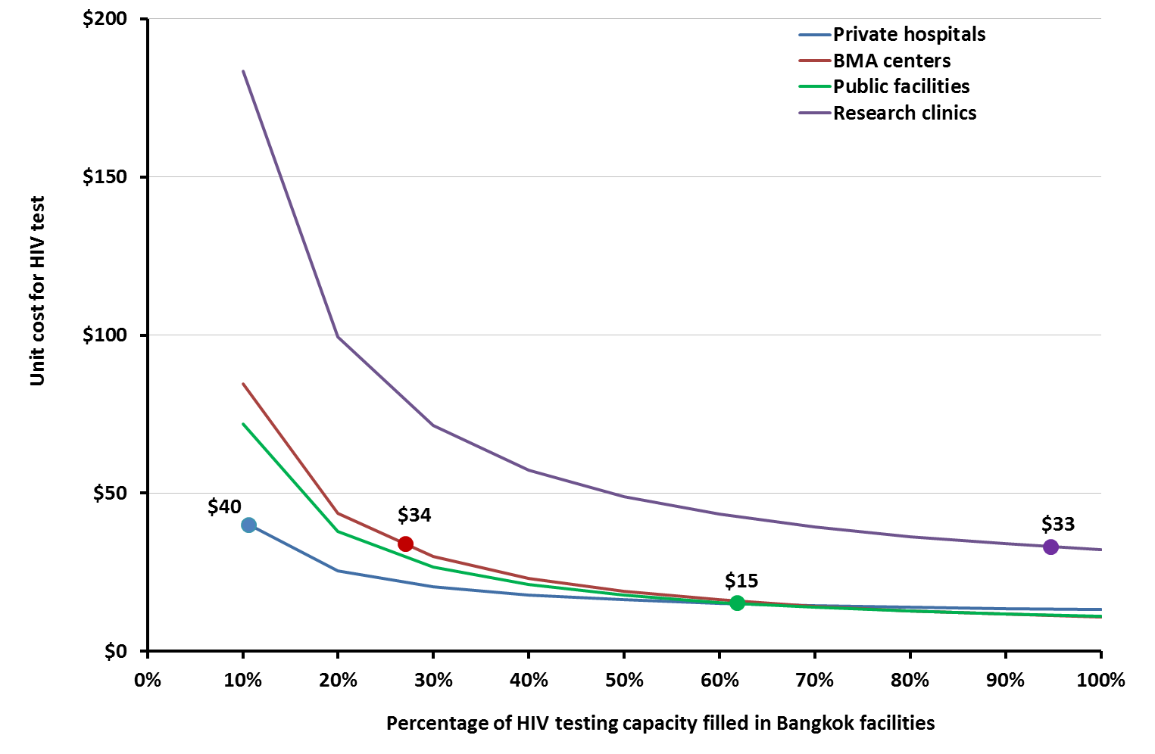

**(b)**

